**The Swallowtail and Birdwing Butterfly Trust (SBBT)**

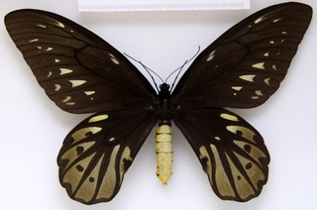Threats to larger animals of the world such as the rhinoceroses and the elephants are well known and extensively recorded. Conversely equally significant threats to certain insect populations of the world are very little understood.

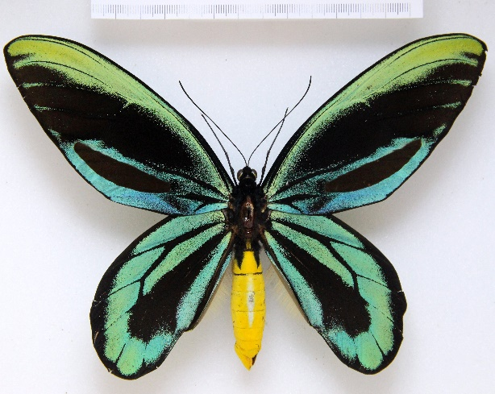Since the 1960’s a vast range of learned scientific papers and reports have been written and published about the issues, and finally now there is a chance to do something about the rapidly declining populations of Swallowtail and Birdwing Butterflies.

This group of butterflies, known as the Papilionidae, includes some of the most beautiful and largest in the world.

The Swallowtail and Birdwing Butterfly Trust (SBBT) is being set up initially to try to develop and enable a sustainable future for the Queen Alexandra’s Birdwing, *Ornithoptera alexandrae*. The female of this, (top photo), is the largest butterfly in the world, and has a wing span of up to 30 cms. That is the size of this sheet of paper!! The males are a little smaller at a mere 20cms (the lower photo).

First discovered in 1906 by A.S. Meek, naturalist to Walter Rothschild in the Northern Province of Papua New Guinea. It is now confined to an area of just a few hundred square kilometres and with an estimated density of less than 10 females per square kilometre, this is arguably the world’s, most endangered and most beautiful species. A recent in-depth study and conservation analysis has brought together all existing knowledge into a book, Queen Alexandra’s Birdwing, by Mitchell, Dewhurst, Tennent and Page (2016) This will, it is hoped, elevate the interest in this remarkable

insect, and subsequently, as a result of gathered knowledge, to other threatened swallowtails and birdwings, including our own British Swallowtail *Papilio machaon*.

With the strong support and encouragement of the oil palm industry in Papua New Guinea, the Trust intends to establish a captive breeding facility to strengthen the wild butterfly populations and provide conservation and training incentives to local landowners.

There are relatively few suitably qualified experts in the world. However all will be contacted, encouraged and incentivised to provide knowledge, initiate programmes and projects that build on the momentum that, it is hoped, this initial project will create.

A founding group of volunteer trustees have committed to developing the Trust and an application is in the process of being finalised for submission to the Charity Commission to establish a new CIO.

(Photos: Courtesy NHM and John Tennent)